Licensing
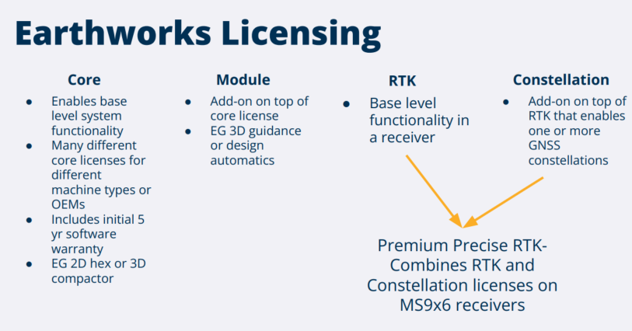
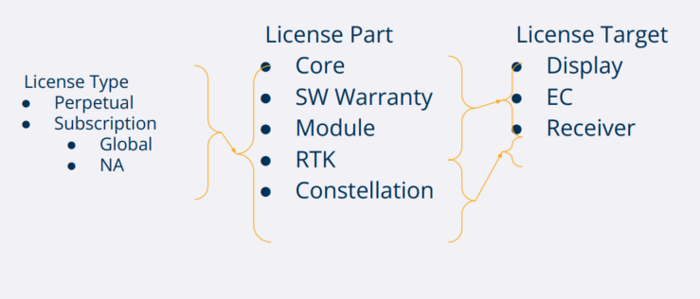
Software Warranty
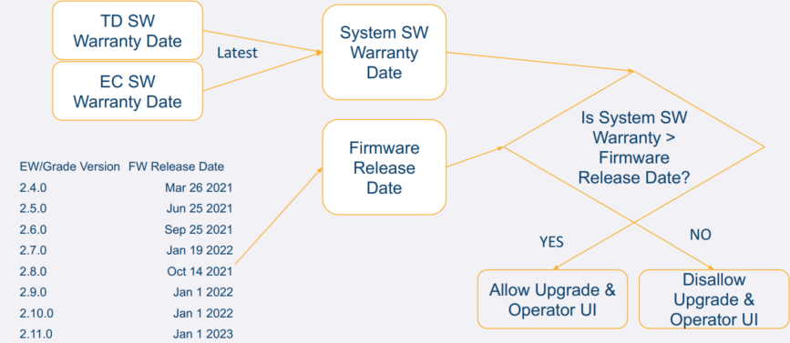
System License
Perpetual - Options
- Option files contain a set of changes
- Options work off of features - not part numbers
- Core license contains SW warranty set to generation date + 5 years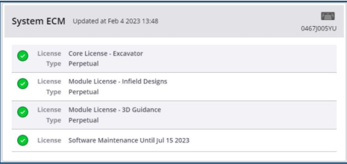
Subscription - Cloud Licensing
- XML file (or OTA) that contains a snapshot of the cloud database
- Most recent file is always used
- Licenses organized by part number
- Each license contains a warning and an expiry date
  - Expiry date on the box is MIN(For Example, TODAY + 45 days, entitlement expiry)
  - Warning is by default a week before expiry
- 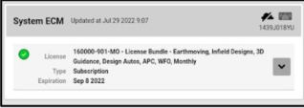
Perpetual Licenses
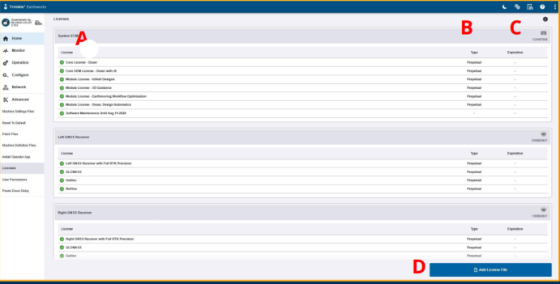
A. License Name
B. License Type
C. License Expiration Date
D. Add New License from file
Licenses
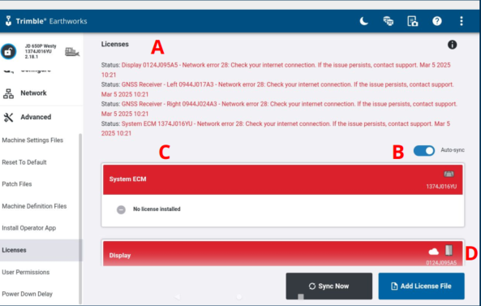
A. Download status/error messaging
B. Auto-sync
C. Missing/Invalid Licenses
D. Cloud License Indicator
Licensing – Trimble Earthworks App
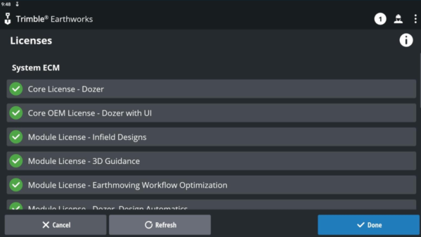
Cloud Licensing – Operator UI
